Idea on Phase Define the Problem Statements

|  |  |
| --- | --- |
| Date | 03 July 2025 |
| Team ID | LTVIP2025TMID36366 |
| Project Name | Pattern Sense: Classifying Fabric Patterns using Deep Learning |
| Maximum Marks | 2 Marks |

Customer Problem Statement Template:

In the tex le and fashion industries, iden fying and categorizing fabric pa erns (e.g., floral, striped, polka dot, geometric) is essen al for inventory management, design cataloguing, quality control, and customer recommenda on systems. Tradi onally, this task relies on manual inspec on, which is me-consuming, subjec ve, and prone to inconsistency.

With the growth of digital fashion pla orms and large-scale tex le produc on, there is a pressing need for an automated, scalable, and accurate method to classify fabric pa erns from images.

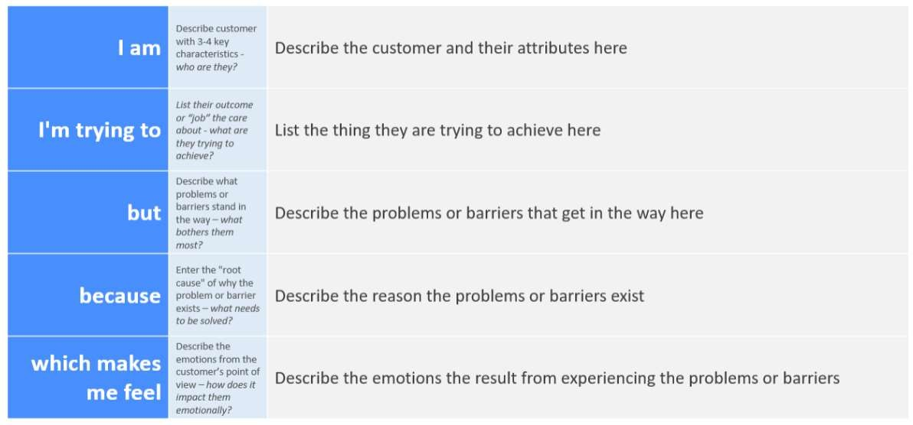

Reference: h ps://miro.com/templates/customer-problem-statement/

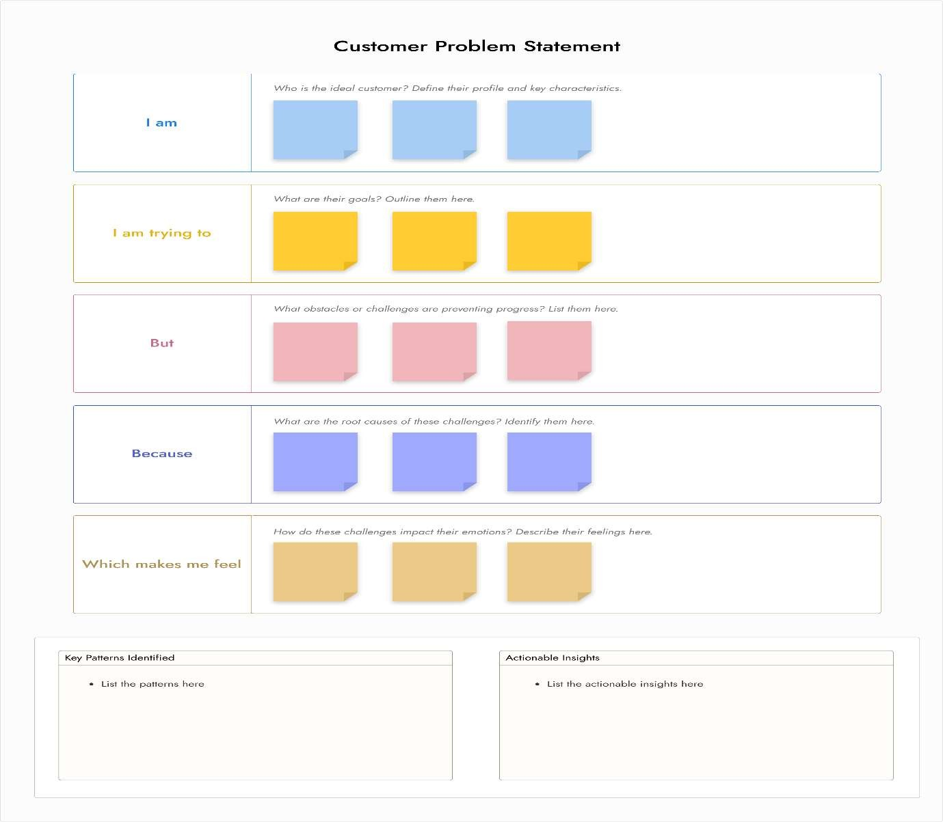

|  |  |  |  |  |  |
| --- | --- | --- | --- | --- | --- |
| Problem  Statement  (PS) | I am  (Customer) | I’m trying to | But | Because | Which makes me feel |
| PS-1 | food processing plant head | make my workers manually sort to separate the  ro en ones  from the fresh produce. | this process is meconsuming and prone to human error. | the whole  process is in manual opera ons | like frustrated |
| PS-2 | Supermarket manager | maintain customer sa sfac on with product freshness | it is difficult to sort  manually | the freshness of these products is crucial | like frustrated to sort |